CHAPTER I

INTRODUCTION

An information system is an integrated set of components for collecting, storing, and processing data and for delivering information, knowledge, and digital products. Business firms and other organization rely on information systems to carry out and manage operations, interact with their customers and suppliers, and compete in the marketplace. Information systems are used to reach their potential customers, to process financial accounts, and to manage their human resources. Others rely on information systems, generally, in doing activities in their daily lives: for socializing, studying, shopping, banking, and entertainment.

The team creates an information system for the organization. It is a technical tool and a capacity building mechanism that supports the Inter-Pacific Study and Migration Consultancy (IPSMC) in the management of regular migration flows from the Philippines, improving migrants’ social status in receiving countries and channeling human and financial resources.

The Inter-Pacific Study and Migration Consultancy Information System (IPSMCIS), help the organization to fully organize the flow of their processes. This system cater three processes for the organization; the application of visa, student and tourist matching, and monitoring of student. Lastly, this system generate reports needed by the company as soon as possible.

* 1. Organizational Background

Inter-Pacific Study and Migration Consultancy started its operation in 2009, it is a visa consultant which provides assistance to Filipinos in their aim to visit, study and migrate to Australia. The company understand that Australia’s migration and legalistic visa system is highly complex and be a daunting process for the unprepared.

* 1. Organization Mission

Therefore, the proponent aim is to make the process as efficient and simple as possible for our clients by providing the best possible advice and services. The company was organized to provide and deliver quality and cost effective migration solutions to all qualified applicants and highly interested Filipino professionals who seek progressive opportunities and better status of life in other countries.

Based on the organization’s mission statement they aim to give Filipinos (students and tourists) a new opportunity outside the country. They wanted to give them a chance to experience the life outside the Philippines and the chance to live there as well.

* 1. Organizational Unit Description

Inter-Pacific Study and Migration Consultancy’s organizational chart is a diagram that shows the structure of their organization and the relationships and relative ranks of its parts and positions or jobs. As shown in Figure 1, the Managing Director is the one who is at the top of the organizational chart. Subordinate of the Managing Director is the Administrative Department which is divided into subordinate groups – Consultant and the International English Language Testing System (IELTS) Department. The Administrative Department captures the migration consultancy function.

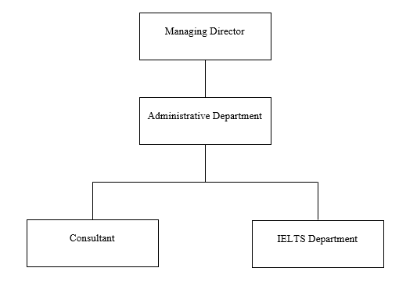 The managing director is the one who overlooks all the process in the organization. Under the managing director, is the administrative department which branch out into two; the IELTS Department be the one to check the score of the IELTS examinees that be needed in the matching process and the Consultant who receives all the requirements and visa application and checks it for verification.

Figure 1. Organizational Chart of Inter-Pacific Study and Migration Consultancy.

1.3.1 Managing Director

Responsible in managing administrative functions to ensure smooth and efficient operations of the organization. Responsible for directing the activities of a specific department or departments within an organization. Manages other employees and ensures all business goals and objectives are reached.

1.3.2 Administrative Department

Responsible in providing administrative and logistical support to the entire organization. They are also responsible for checking all the requirements that the consultant pass to them. Lastly, they are the one who are maintaining the budget and the one who is coordinating with the managing director.

* + 1. Consultant

Responsible of fixing or improving a particular component of business. They are responsible of providing advice, make recommendations and excel at problem solving. They are also responsible for checking and verifiying all the requirements that the client send to them.

1.3.4 International English Language Testing System (IELTS) Department

Responsible of providing application forms to students who are willing to take the IELTS Review and assist them when the examination for the IELTS is ready. They are the one who is responsible for giving the IELTS result to the company.

* 1. Current System Description

This section of the chapter shows the manual process of the Inter-Pacific Study and Migration Consultancy (IPSMC). The first diagram shows the context data flow diagram of the organization – created for the purpose of systems analysis and design and it also shows the scope and boundaries of a system at a glance. Next diagram shows the first explotion of the data flow diagram – this includes the major processes that the manual operations of the organization cater. Succeeding three diagrams shows the second explosion of the data flow diagram of each of the processes in the first explosion, this time in a more detailed one.

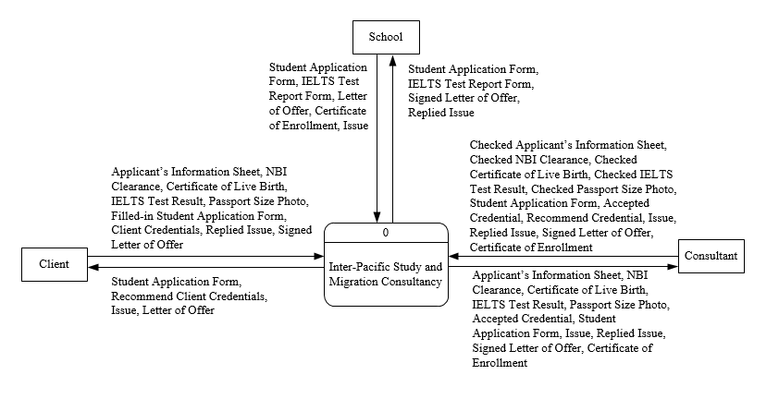Figure 2 shows the Inter – Pacific Study and Migration Consultancy Context Data Flow Diagram. This diagram shows all the transactions process that in the organization. The clients must comply all the following requirements for visa application to be checked by the consultant. The consultant is the one who accept those requirements whether it is complete or not. If the requirements are complete the consultant endorses those requirement to the embassy. The waiting period of the company consultant for the client’s visa is 14 days. Once the process of the visa is completed, the consultant informs their clients for the distribution of visa.  
Figure 2. Context Data Flow Diagram of Inter-Pacific Study and Migration Consultancy.

Figure 3 shows the first explosion of Inter – Pacific Study and Migration Consultancy.

It shows all the process of the company from visa application of clients to generating of all the reports. After the approval of requirements, the next process is the matching. The consultant assigned the school and program of the study to their clients which depends to their budget. The school send their area of concern for those students sent abroad to the consultant for the monitoring purposes. After the data entries, transaction processes and monitoring, the generation of all the reports is provided by the consultant.

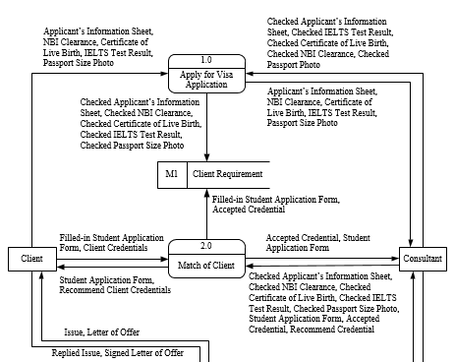

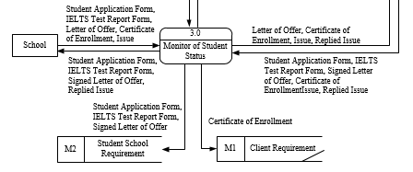

Figure 3. First Explosion Diagram of Inter-Pacific Study and Migration Consultanc

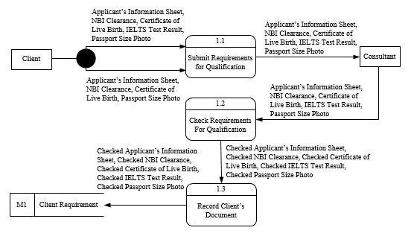 Figure 4 shows the second explosion of the first process which is visa application. The clients both tourist and students must bring all the requirements needed by the company. It includes the Applicants Information Sheet, NBI Clearance, Certificate of Live Birth, IELTS Test Results. On the students side, all the requirements is needed by the company for them to study abroad but on the tourists side the EILTS Test Result is not needed to travel abroad. The consultant is the one who checks the completion of requirements and keep the requirements needed for the client’s document records. The consultant sends all the client’s requirements needed for visa application and wait for 14 days for the distribution of visa.

Figure 4. Second Explosion Diagram of Inter-Pacific Study and Migration Consultancy-Visa Application.

Figure 5 shows the second explosion of the second process which is match of student to overseas school. The students must fill in the students application form that is provided by the consultant. The consultant checked all the requirements needed to study abroad. After the completion of requirements, the consultant recommend the possible universities and program of the study for their clients outside the country. The recommendation of countries, schools and program of the study depends on client’s budget.

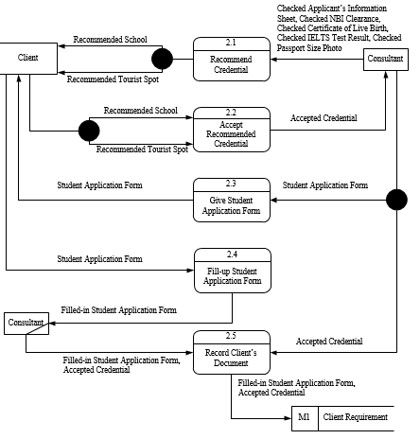

Figure 5. Second Explosion Diagram of Inter-Pacific Study and Migration Consultancy-

Matching.

Figure 6 shows the second explosion of the third process which is monitor the student tuition status.

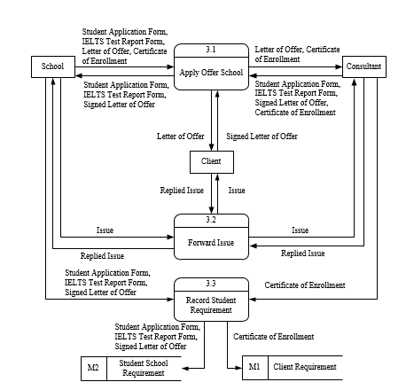

Figure 6. Second Explosion Diagram of Inter-Pacific Study and Migration Consultancy –

Monitoring.­­­­­­­

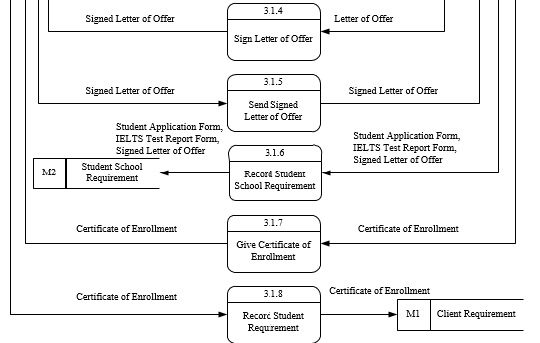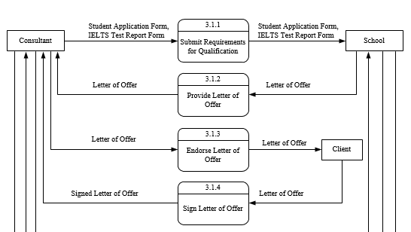

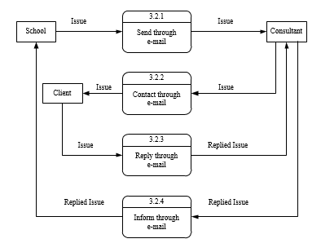

In this chapter, the team had presented the current flow of the organization. This section includes the organizational background, organizational mission, organizational unit description, current system description and the context diagrams followed by the second explosion. It also use to guide the readers about the manual process that happen in the organization base on the context diagrams that been shown. Each diagrams has a description so that it’s understandable to the reader.